**OOP WS26 EXAM2 REVIEW Q 61-70**

**DATE: 20th january 2022**

1.- Computer /1

2.- FrmCOmputer /1

3.- DBManager /1

4.- three packages /1

5.- dependencies /1

1.- menu /1.25

2.- add Computer /1.25

3.- listComputer /1.25

4.- updateComputer /1.25

5.- deleteComputer /1.25

Other solution: one screen with all buttons on it

1.- inputs /1

2 - 5.-buttons /4

0 Edison Lascano 3 + 4.2 = 7.2/10

14 CORREA RUIZ KERLY YADIRA 2+8= 10/10

Inspector Darling Cruz

1.- Computer 0/1

2.- FrmCOmputer 0/1

3.- DBManager 1/1

4.- three packages 1/1

5.- dependencies 0/1

Total 2/5

1.- menu 1.25/1.25

2.- add Computer 0/1.25

3.- listComputer 1.251.25

4.- updateComputer 1.25/1.25

5.- deleteComputer 1.25/1.25

Other solution: one screen with all buttons on it

1.- inputs 0/1

2 - 5.-buttons ¾

Total 8 /5

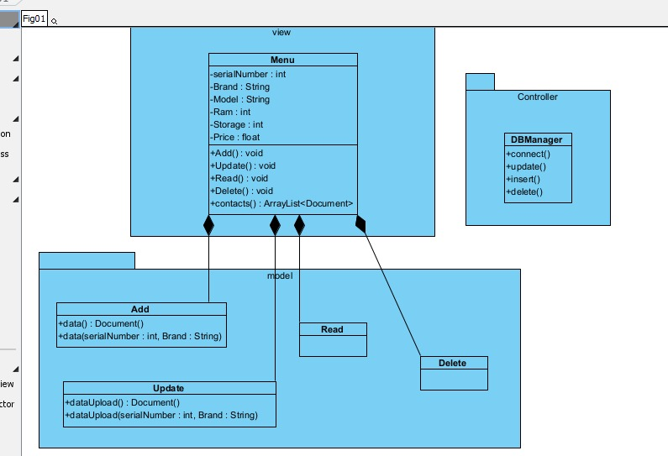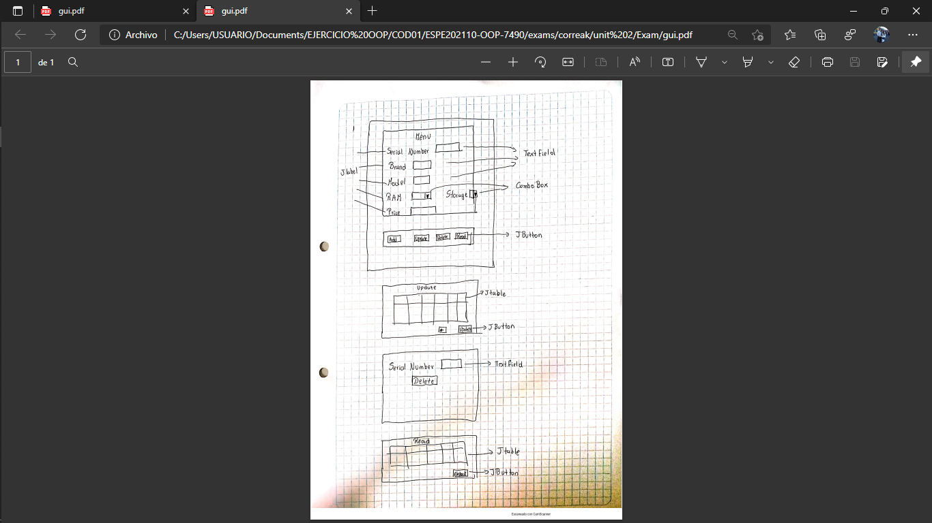

15 CRUZ PANTOJA DARLING MICAELA  
  
Inspector Alejandro De La Cruz

1.- Computer 1/1

2.- FrmCOmputer 0/1

3.- DBManager 1/1

4.- three packages 0/1

5.- dependencies 1/1

Total 3/5

1.- menu 1/1.25

2.- add Computer 1/1.25

3.- listComputer 1/1.25

4.- updateComputer 1/1.25

5.- deleteComputer 1/1.25

Total 3+5 = 8/10

